October 12, 2021

COVID-19 NOTIFICATION: Salt River Elementary School

Dear SRES Families,

We recently became aware of an individual from Salt River Elementary School with a test-confirmed case of COVID-19. They were last at SRES on Monday, Oct. 11. Due to federal privacy laws, we are unable to share any personal identifying information about who has tested positive.

We have notified the Community Epidemiologist and health department. Students and staff who have been in close contact with this individual will be contacted directly. If you do not receive a follow-up call, then you were not in close contact (within 6 feet for 15 minutes or more) with the individual.

We encourage everyone to follow SRPMIC health guidelines and monitoring your family’s health over these next two weeks. If your student experiences symptoms of COVID-19, seek medical care and/or isolate at home. Please inform school leaders if your student tests positive for COVID-19.

For more information about COVID-19, including how it’s spread, its symptoms, and prevention methods, visit saltriverschools.org/news/what_s_new/covid-19. Additional information is available on the Centers for Disease Control website at www.cdc.gov.
If there are any additional questions, please contact me at 480-362-2400.

Thank you,

Dr. Amanda Guerrero
SRES Principal
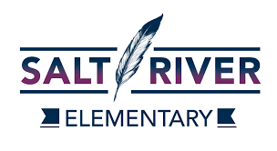
MATT’O T’VE:M AB O JU: | O’odham
MAT ASHEEVK UUWESHUUM | Piipaash
WE WILL DO THIS TOGETHER | English

